Question 1
The following is the sender.
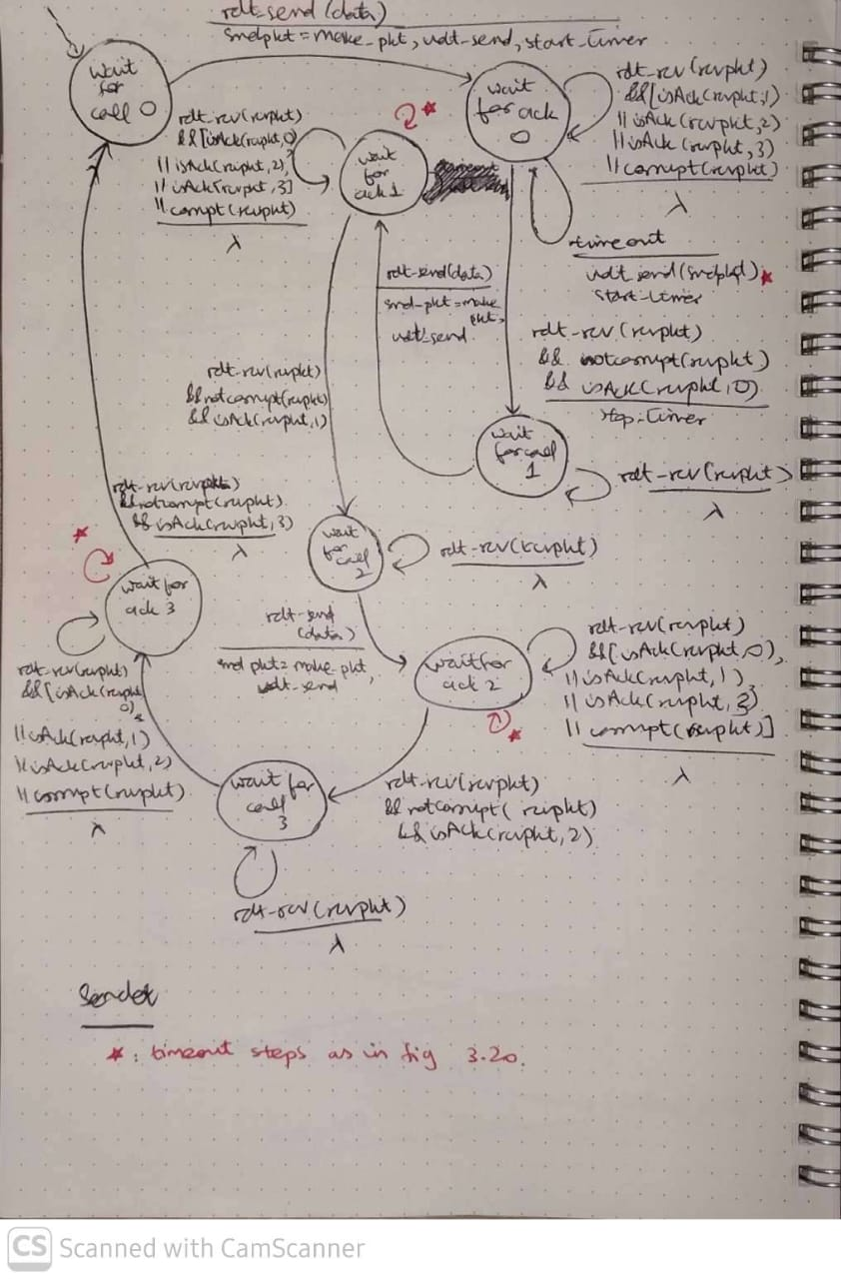
The red arrow marks will have the same timeout steps as in the following figure
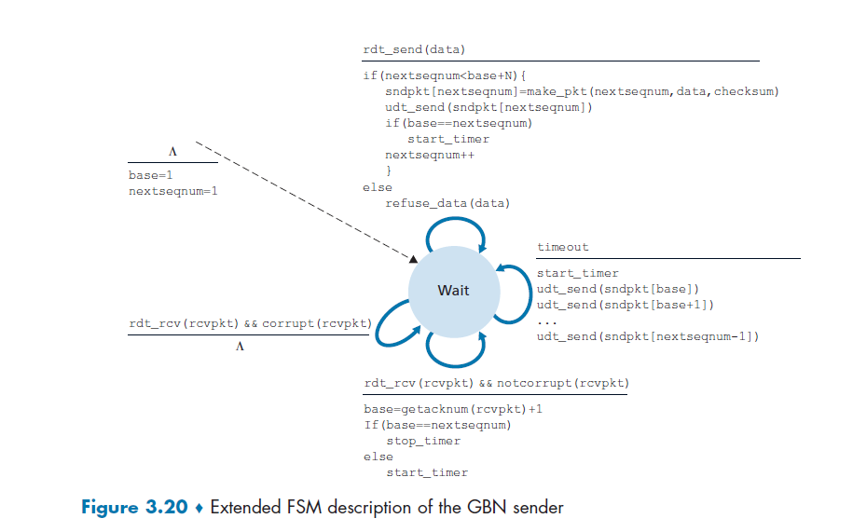
In the same way, the following receiver will be extended to two more packets(just add ACK numbers as have been added for sender):
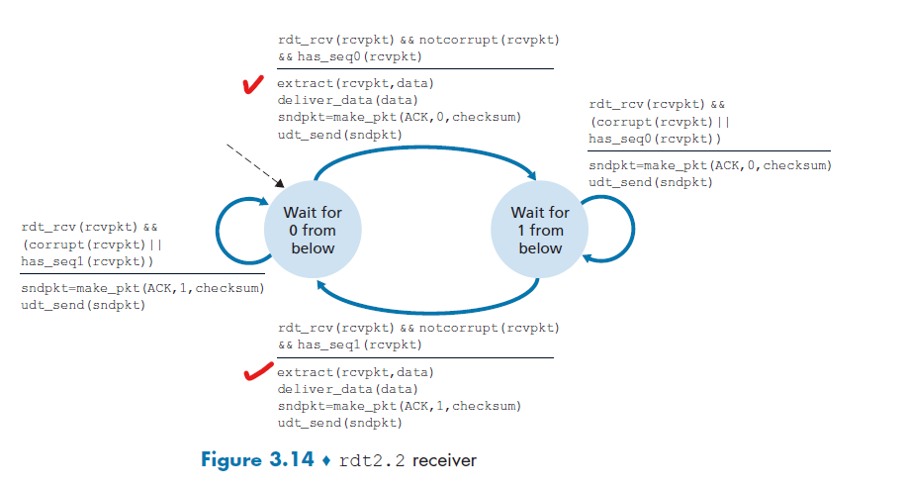
[receiver of 2.2 and 3.0 is same]
Red tick marked are replaced by following ticks
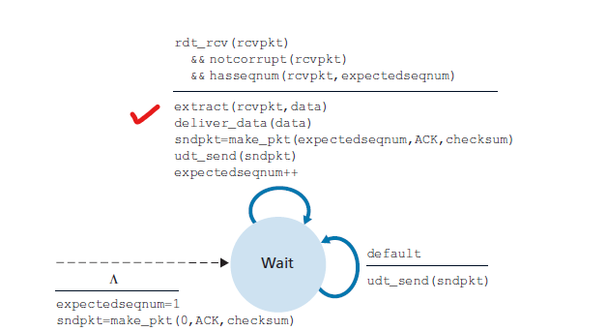

Question 2
